ICS344 Secure Communication System - Technical Report
Project: Cryptography in Action – Secure Messaging Application
Bucket: P01 (Python | AES-CBC PKCS#7 | Diffie-Hellman | Desktop)
Team: ICS344 Project Team 41
Members: Muhammad Jaddoua – Husain Althagafi
Institution: King Fahd University of Petroleum & Minerals
Date: November 2025

Abstract
This report presents a secure communication system developed for the ICS344 course, demonstrating fundamental cryptographic principles through an interactive desktop application. Built with Python and PyQt5, the system implements AES-256-CBC encryption with PKCS#7 padding and classic Diffie-Hellman key exchange, while providing simulations of four security attacks: dictionary attacks, message injection, session hijacking, and message flooding. The report details cryptographic design, system architecture, GUI workflow, attack methodologies, and security evaluation with identified limitations.
Keywords: Cryptography, AES-CBC, Diffie-Hellman, Attack Simulation, Desktop Security Application

Table of Contents
- Introduction
- Project Objectives
- Cryptographic Design
- System Architecture
- GUI Design and Workflow
- Attack Simulations
- Security Evaluation
- Limitations and سFuture Work
- Conclusion
- References

1. Introduction

1.1 Background and Scope
In modern digital communications, cryptographic protocols form the foundation of secure systems. This project implements a functional secure messaging system demonstrating core cryptographic concepts in an interactive manner, allowing users to observe encryption/decryption in real-time and understand how security attacks operate.
The Secure Communication System is a desktop application developed per P01 specifications: Python implementation, AES-CBC with PKCS#7 padding, classic Diffie-Hellman key exchange, and simulations of Dictionary, Message Injection, Session Hijacking, and Flooding attacks. The application simulates two-client communication within a single window, showing the complete workflow from key establishment to encrypted message exchange.

1.2 Motivation
This project bridges the gap between theoretical cryptography and practical implementation, providing hands-on experience with real security challenges. It demonstrates that strong cryptographic primitives can still be vulnerable to implementation flaws or protocol-level attacks, emphasizing holistic security design. The project serves as both an educational tool and a portfolio demonstration of security programming competency.

2. Project Objectives

2.1 Primary Objectives
Objective 1: Implement Symmetric Encryption
Develop AES-256 encryption using CBC mode with PKCS#7 padding, demonstrating understanding of block cipher modes and padding schemes.
Objective 2: Implement Secure Key Exchange
Implement classic Diffie-Hellman protocol using cryptographically secure parameters, properly deriving encryption keys from the shared secret.
Objective 3: Create Interactive User Interface
Design a graphical interface allowing intuitive interaction with cryptographic functions through clear logging and visual feedback.
Objective 4: Simulate Security Attacks
Implement four distinct attacks: dictionary attacks on keys, message injection, session hijacking via MITM, and message flooding DoS.
Objective 5: Demonstrate Security Principles
Show fundamental concepts including confidentiality, key management importance, and the distinction between encryption and authentication.

2.2 Technical Requirements
- Python 3.8+ with pycryptodome library for cryptographic primitives
- PyQt5 framework for desktop GUI
- Cross-platform support (Windows, macOS, Linux)
- Comprehensive security event logging
- Proper error handling and secure coding practices

3. Cryptographic Design

3.1 Symmetric Encryption: AES-CBC
Algorithm Selection: AES-256 was chosen for its proven security (20+ years of cryptanalysis), hardware acceleration support (AES-NI), standardization (FIPS 197), and availability of well-tested implementations.
CBC Mode: Cipher Block Chaining provides plaintext pattern hiding through XOR operations with previous ciphertext blocks. Each message uses a cryptographically random initialization vector (IV), ensuring identical plaintexts produce different ciphertexts. The encryption follows:
C[i] = E(K, P[i] ⊕ C[i-1])
Where:
- C = ciphertext
- P = plaintext
- K = key
- E = encryption function
PKCS#7 Padding: Block ciphers require fixed-size inputs (128 bits for AES). PKCS#7 padding appends N bytes of value N when N bytes are needed, providing unambiguous padding removal during decryption.
Implementation: Uses pycryptodome library following this workflow:
Encryption:
- Generate random 16-byte IV
- UTF-8 encode plaintext
- Apply PKCS#7 padding
- Encrypt with AES-CBC
- Concatenate IV+ciphertext
- Base64 encode
Decryption:
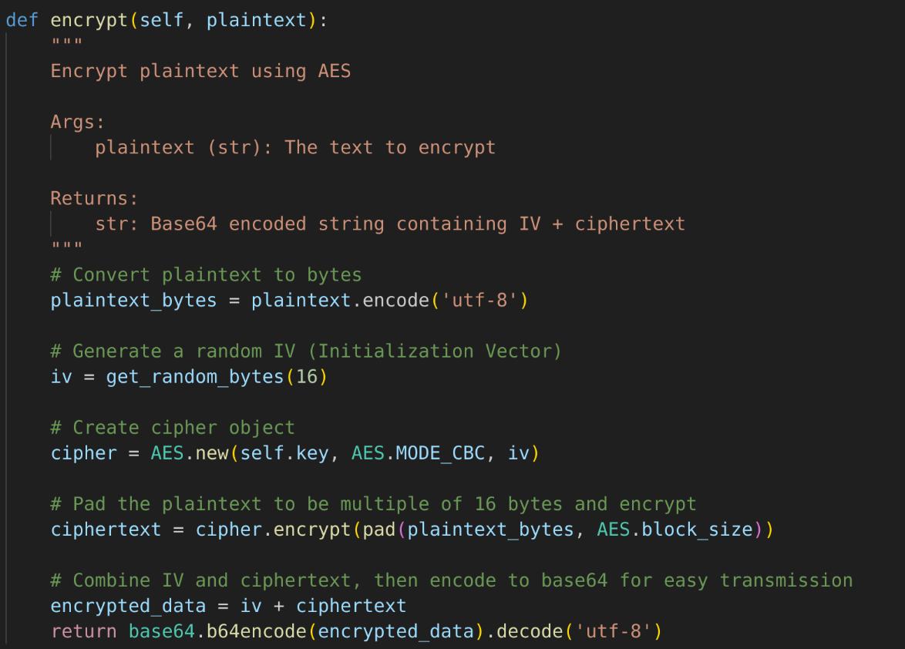Figure 1: AES encryption implementation
- Base64 decode
- Extract IV and ciphertext
- Decrypt
- Remove padding
- UTF-8 decode
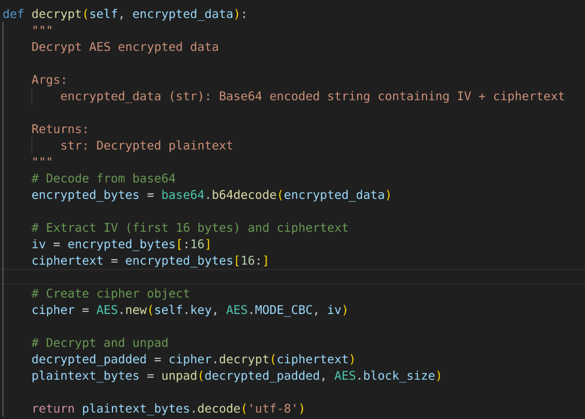Figure 2: AES decryption implementation

3.2 Key Exchange: Diffie-Hellman
Protocol Overview: The Diffie-Hellman protocol enables shared secret establishment over insecure channels. Alice and Bob each generate private keys (a, b), compute public keys (A=g^a mod p, B=g^b mod p), exchange public values, then independently compute the same shared secret s=g^(ab) mod p. Security relies on the discrete logarithm problem's computational difficulty.
Parameters: Uses RFC 3526 Group 14 (2048-bit MODP) with prime p and generator g=2. This provides ~112 bits of security, sufficient for current threats.
Key Derivation: Raw DH output is hashed with SHA-256 to produce a 32-byte AES key:
shared_secret_bytes = int_to_bytes(g^(ab) mod p, 256 bytes)
aes_key = SHA256(shared_secret_bytes) # Produces 32 bytes for AES-256
This ensures:
- Fixed output length (256 bits) suitable for AES-256
- Uniform distribution of key bits
- One-way transformation (computing shared_secret from aes_key is infeasible)
Security Properties: DH resists passive eavesdropping (discrete logarithm hardness) and requires no pre-shared secrets. However, it lacks authentication (vulnerable to active MITM), non-repudiation, and message integrity.

3.3 Additional Security Mechanisms
Random Number Generation: Uses Python's secrets module and pycryptodome's get_random_bytes(), both utilizing OS cryptographic RNGs (/dev/urandom on Linux/macOS, CryptGenRandom on Windows).
Base64 Encoding: All ciphertext is Base64-encoded for safe text-based transmission and GUI display, with ~33% size overhead.

4. System Architecture

4.1 Component Organization
The system uses three-layer architecture:
Cryptographic Layer (aes_encryption.py, diffie_hellman.py): Core encryption/decryption and key exchange, independent of GUI and reusable.
User Interface Layer (GUI/gui.py, GUI/main_window.py): User interactions, displays, and event processing via Qt Designer-generated interfaces.
Application Logic Layer (GUI/main_window.py): Coordinates cryptographic and UI layers, implements attack simulations, manages application state.
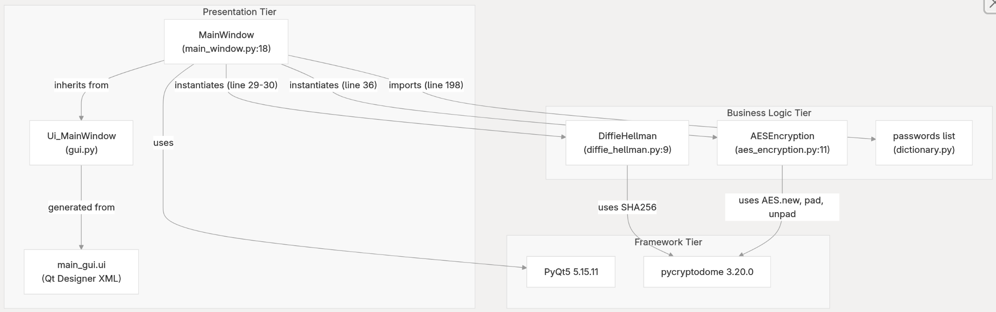Figure 3: System architecture layers

4.2 Module Descriptions
AESEncryption Module: Encapsulates AES-CBC with automatic IV generation, padding handling, string-based interface, and Base64 encoding.
DiffieHellman Module: Implements classic DH with RFC 3526 parameters, SHA-256 key derivation, and separate methods for key generation and secret computation.
GUI Module: Auto-generated gui.py from Qt Designer defines window layout; main_window.py extends it with button handlers, encryption/decryption logic, attack simulations, and logging.

4.3 Data Flow
Startup Flow:
Initialize PyQt5 → Create DH instances → Perform key exchange →
Derive AES key → Display GUI → Log completion
Message Encryption:
User types message → Clicks "Encrypt & Send" →
AES-CBC encryption (random IV, padding, encrypt, Base64) →
Display ciphertext → Log event
Message Decryption:
Ciphertext present → User clicks "Decrypt & Verify" →
Decode Base64 → Extract IV → Decrypt → Remove padding →
Display plaintext → Log success
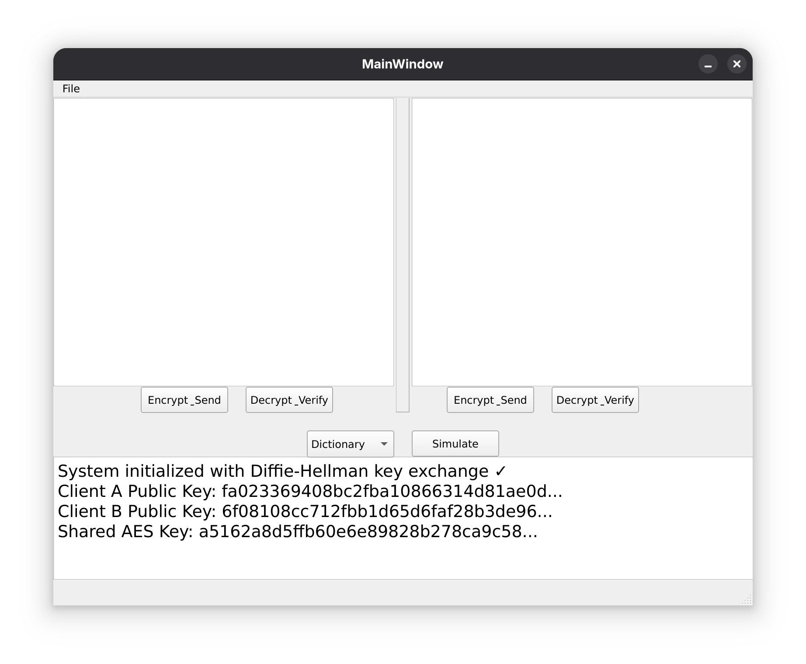Figure 4: Startup logs

5. GUI Design and Workflow

5.1 Interface Layout
Client Panels: Two symmetric panels (A and B) with text areas and "Encrypt & Send" / "Decrypt & Verify" buttons.
Attack Controls: Dropdown menu for attack selection with "Simulate" button.
System Log: Auto-scrolling panel showing key exchange, encryption/decryption, and attacks.
Figure 5: Main application window with labeled components

5.2 Design Rationale
The two-panel design clarifies the two-party system with visible message flow. Minimal buttons reduce cognitive load. The log panel provides continuous educational feedback. Both plaintext and ciphertext visibility demonstrates encryption's transformation. Identical client interfaces emphasize symmetric communication.

5.3 User Workflow
Standard Message Exchange:
1. User types message in Client A
2. Click "Encrypt & Send"
3. Observe ciphertext in Client B
4. Click "Decrypt & Verify"
5. Observe plaintext restoration
Attack Simulation:
1. Select attack type from dropdown menu
2. Click "Simulate" button
3. Observe attack execution in real-time
4. Read defense analysis in system logs
Message encryption sequence
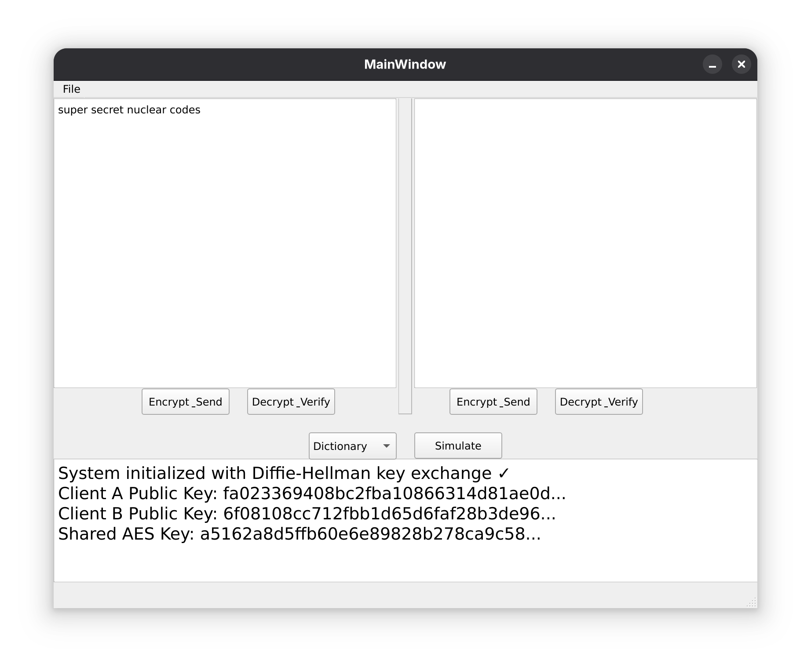
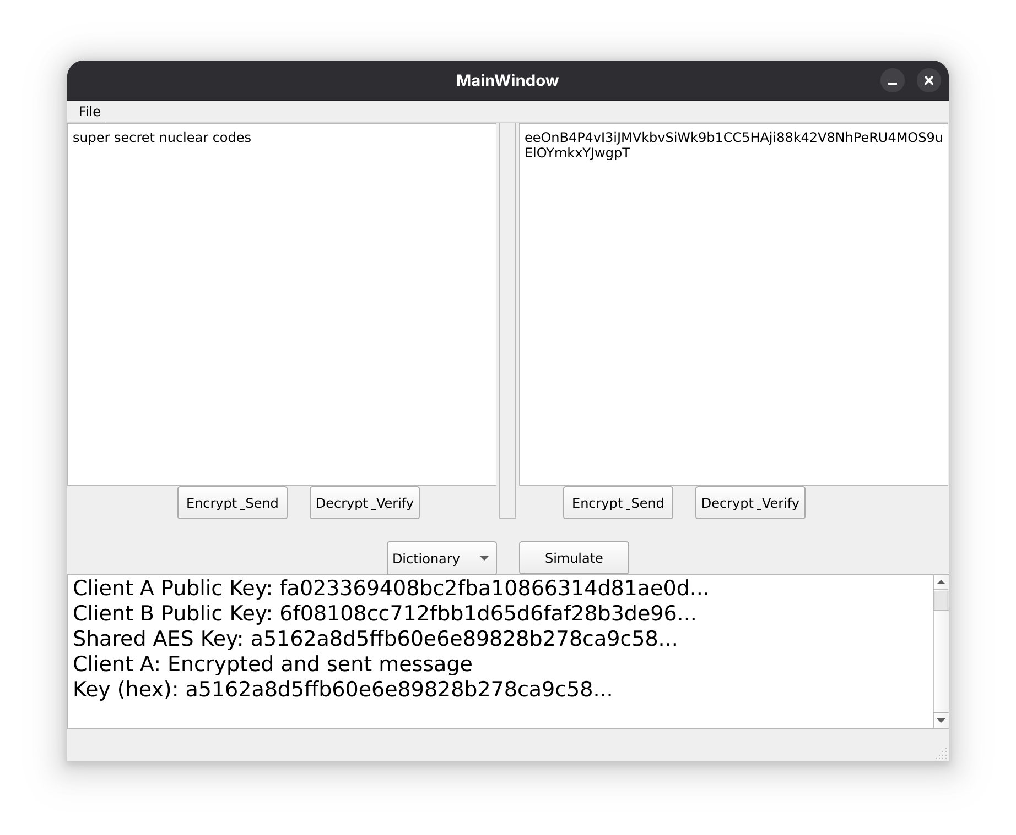
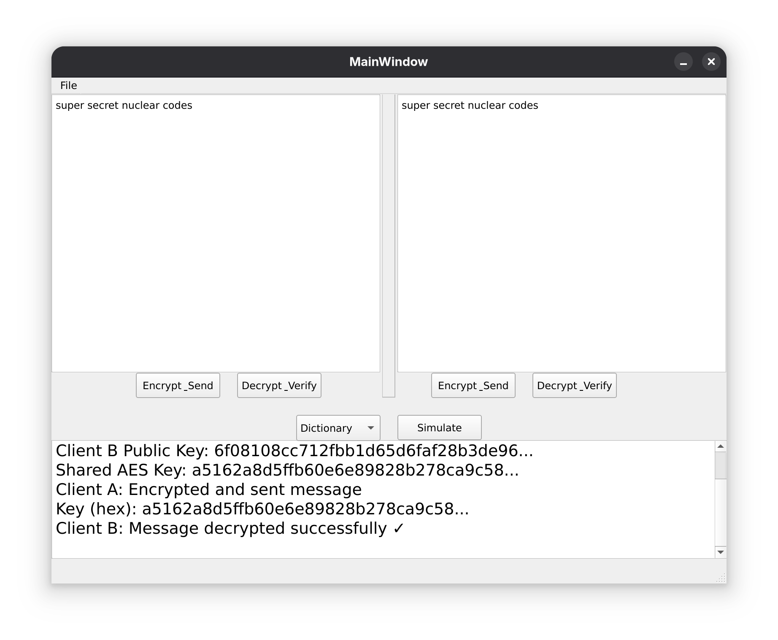

5.4 Qt Designer Integration
GUI designed visually in main_gui.ui → Generated to Python with pyuic5 → Extended in main_window.py. This separates design from logic, enables visual iteration, and ensures professional conventions.

6. Attack Simulations

6.1 Dictionary Attack
Description: Brute-force key guessing using common password lists. This simulation demonstrates why dictionary attacks fail against cryptographically random 256-bit keys.
Implementation: Attempts common passwords ["password", "123456", "admin", "qwerty", "secret"] against the AES key, logging each failure and explaining computational infeasibility (2^256 keyspace requires ~10^57 years at 1 trillion keys/second).
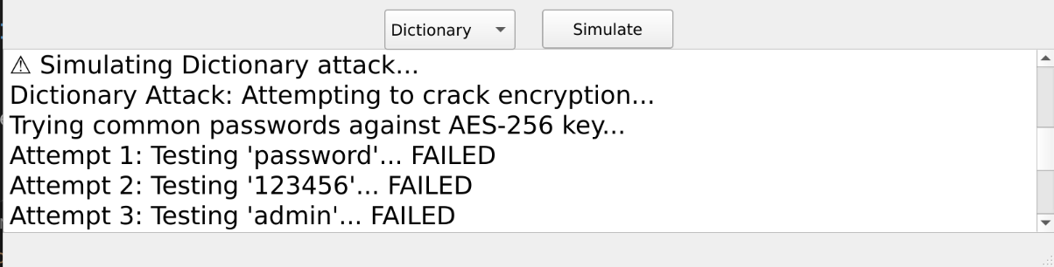Figure 6: Dictionary attack failed attempts part 1
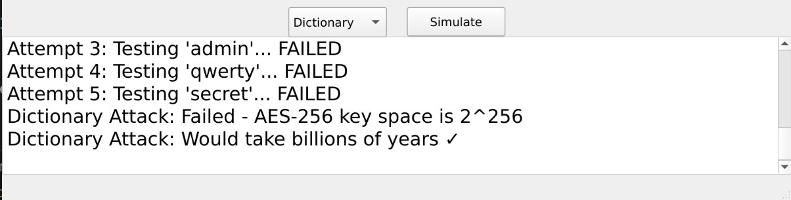Figure 7: Dictionary attack failed attempts part 2
Lesson: Strong cryptographic keys resist brute-force. Key quality (random generation) matters as much as algorithm strength.

6.2 Message Injection Attack
Description: Demonstrates that encryption provides confidentiality but not authenticity. An attacker with the key can forge valid encrypted messages.
Implementation: Attacker obtains shared key → Creates malicious plaintext "HACKED MESSAGE" → Encrypts with shared key → Injects into Client A → System logs the successful injection.
Security Analysis: AES-CBC doesn't verify message origin. Encryption ≠ Authentication. Defense requires MAC/HMAC or authenticated encryption modes (AES-GCM).
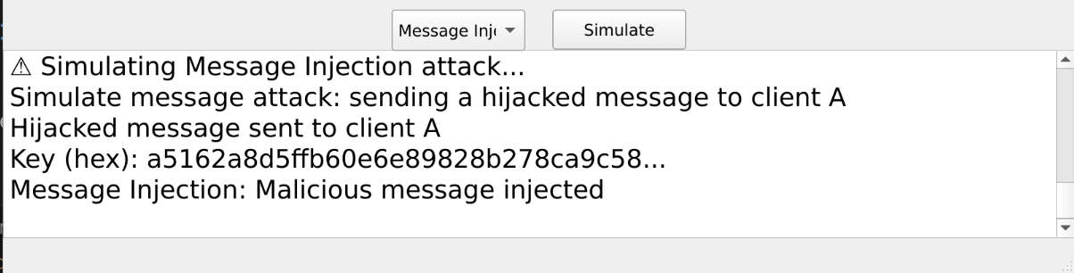Figure 8: Injected forged message

6.3 Session Hijacking (MITM)
Description: Man-in-the-middle attack simulation showing passive eavesdropper's failure to compute DH shared secret.
Implementation: Attacker observes public key exchange → Generates own DH key pair → Attempts to compute shared secret → System compares real vs. attacker's "secret" → Keys don't match → Attack fails.
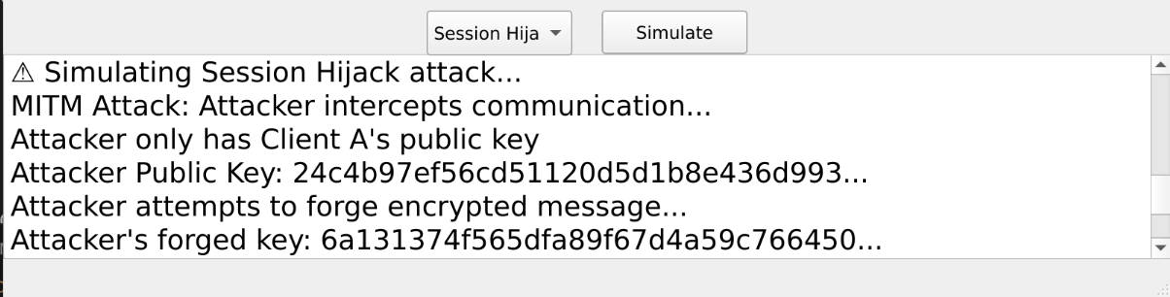Figure 9: Injected forged message part 1
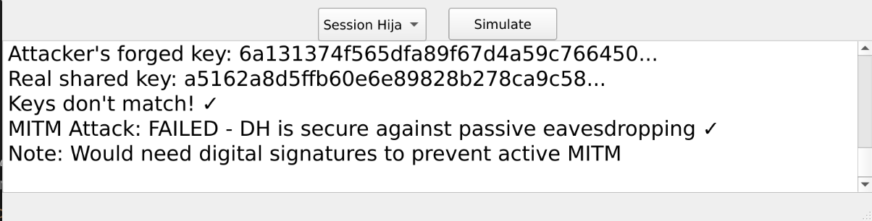Figure 10: Injected forged message part 2
Security Analysis: DH resists passive eavesdropping (discrete logarithm problem). However, active MITM (intercepting and modifying exchange) requires authentication via certificates or digital signatures.

6.4 Flooding Attack
Description: Denial-of-Service via message volume overwhelming system resources.
Implementation: Rapid loop generating 10 encrypted messages → Logs each transmission → Displays defense recommendations (rate limiting, connection throttling).
Security Analysis: Even efficient encryption can't prevent resource exhaustion. Availability requires rate limiting, network throttling, CAPTCHA, and traffic analysis beyond cryptographic mechanisms.
6.5 Summary
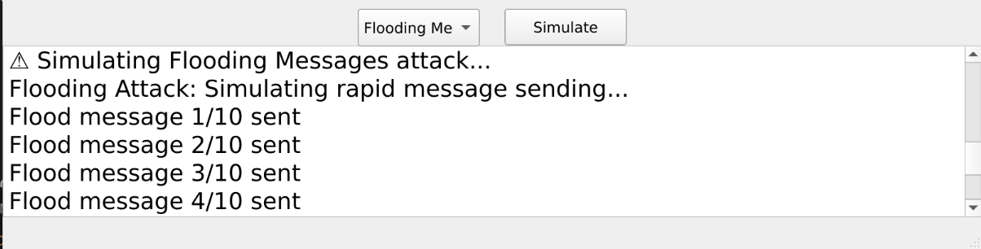Figure 11: Flooding logs part 1
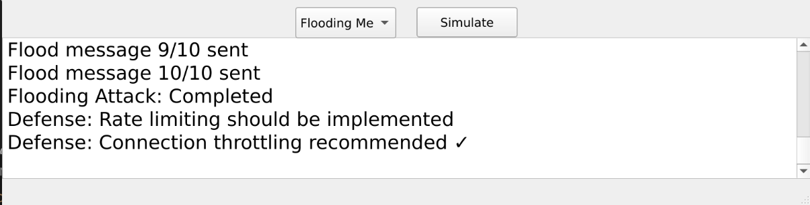Figure 12: Flooding logs part 2
The four attacks demonstrate:
- Dictionary Attack: Strong cryptographic keys resist brute-force
- Message Injection: Encryption alone doesn't guarantee authenticity
- Session Hijacking: DH resists passive eavesdropping but needs authentication
- Flooding: Availability requires resource management beyond encryption

7. Security Evaluation

7.1 Cryptographic Strength
AES-256-CBC Strengths: Proven algorithm, CBC pattern concealment, random IV, correct PKCS#7 padding, 256-bit long-term security.
AES-256-CBC Limitations: Vulnerable to padding oracle attacks if errors exposed, no integrity protection, susceptible to bit-flipping attacks.
DH Strengths: 2048-bit standardized parameters, passive eavesdropping resistance, no pre-shared secrets, proper SHA-256 derivation.
DH Limitations: Vulnerable to active MITM without authentication, static keys (no ephemeral DH), no perfect forward secrecy, no identity verification.

7.2 Implementation Security
Positive Aspects: Uses well-tested libraries (pycryptodome), OS cryptographic RNGs, no hardcoded secrets, clear separation of concerns.
Areas for Improvement: Key material in memory vulnerable to dumps, no secure deletion, error messages could leak padding information, limited input validation.

7.3 Protocol Security
Achieved: ✅ Confidentiality (AES-256), ✅ Key Agreement (DH), ✅ Computational Security
NOT Achieved: ❌ Authentication, ❌ Integrity, ❌ Non-repudiation, ❌ Perfect Forward Secrecy, ❌ Replay Protection

7.4 Threat Model
Defended: Passive eavesdropping, dictionary attacks on keys, pattern analysis
NOT Defended: Active MITM, message tampering, replay attacks, key compromise, DoS (limited)

7.5 Comparison with Production Systems
Signal Protocol: AES-GCM, Double Ratchet forward secrecy, MAC, key fingerprints
TLS 1.3: Authenticated encryption, ephemeral DH, certificates, formal verification
Our Implementation: Educational focus, fundamental mechanisms, deliberate simplifications, suitable for learning only

8. Limitations and Future Work

8.1 Critical Limitations
No Message Authentication: MACs/signatures absent; attackers with keys can forge messages, tampering undetected. Future: HMAC-SHA256 or AES-GCM.
Static Keys: DH keys reused throughout session; compromise decrypts all messages. Future: Ephemeral DH with periodic rekeying.
No Identity Verification: Cannot verify communication party; vulnerable to active MITM. Future: X.509 certificates or TOFU with key fingerprints.
Single-Instance Simulation: Both clients in same application; not true network protocol. Future: TCP/UDP sockets for multi-machine communication.
No Session Management: Cannot handle reconnections, state persistence, timeouts. Future: Session IDs, timeouts, renegotiation triggers.
GUI Thread Blocking: Heavy crypto on main thread could freeze UI. Future: Background threading with QThread/asyncio.

8.2 Missing Features
Digital Signatures: No RSA/ECDSA; cannot prove origin or non-repudiation. Future: RSA signature integration.
PKI: No certificate infrastructure; cannot verify public keys. Future: Simple certificate system.
Secure Storage: Keys lost on close; no persistent sessions. Future: Encrypted keystore with master password.
Multi-User Support: Only two clients; no group messaging. Future: Multiple clients with roster management.
Message History: No persistent storage or conversation review. Future: Encrypted message database.

9. Conclusion

9.1 Achievements
This project successfully demonstrates secure communication per P01 specifications:
Cryptographic Implementation: AES-256-CBC with PKCS#7 padding providing strong confidentiality with random IVs preventing pattern analysis.
Key Exchange: Classic Diffie-Hellman with RFC 3526 parameters enabling shared secret establishment without prior secure channels.
User Interface: Intuitive PyQt5 desktop application with real-time cryptographic operation observation and comprehensive logging.
Attack Simulations: Four distinct attacks demonstrating computational infeasibility of brute-force, encryption vs. authentication distinction, DH passive eavesdropping resistance, and availability protection needs.
Educational Impact: Successfully bridges theoretical cryptography and practical implementation with hands-on security concept experience.

9.2 Key Lessons
Cryptography is Complex: Even "simple" encryption requires careful attention to padding, IV generation, key derivation. Well-tested libraries essential.
Encryption Alone Insufficient: Message injection clearly shows confidentiality ≠ integrity/authentication. Multiple complementary mechanisms required.
Security is Contextual: No absolute security; appropriate to threat model. Educational tradeoffs differ from production requirements.
Limitations Matter: Understanding what systems DON'T protect is as critical as understanding protections. Honest assessment enables better security decisions.

9.3 Objectives Met
All five primary objectives achieved per P01 specifications:
- ✅ Objective 1: AES-256-CBC with PKCS#7 padding
- ✅ Objective 2: Classic Diffie-Hellman with proper parameters
- ✅ Objective 3: Intuitive desktop GUI with feedback
- ✅ Objective 4: Four required attack simulations
- ✅ Objective 5: Security principles demonstration

9.4 Final Thoughts
Secure communication underpins modern computing. This project provides foundational understanding of encryption algorithms, key exchange protocols, and security attacks, the same principles in production systems used by billions daily.
While intentionally simplified for education, the core concepts demonstrated here translate to real-world security. The limitations discussed aren't failures but learning opportunities. True security requires understanding basics first, then adding sophistication: authentication, forward secrecy, secure channels, defense-in-depth.
This project serves as a starting point for deeper cryptography exploration. The field is vast, evolving, and critically important. Every student gaining practical understanding becomes better equipped to build secure systems our digital society depends upon.

9.5 Recommendations
For Students:
- Experiment with the code and modify parameters
- Exploit the identified limitations
- Research how production systems address these issues
- Use this as a foundation for further study
For Instructors:
- Use as a demonstration tool in cryptography lectures
- Assign extensions as homework (add HMAC, implement RSA signatures)
- Have students conduct security reviews and propose improvements
- Encourage implementation of the future work items
For Practitioners:
- Recognize this as an educational tool, not production code
- Use it to explain security concepts to non-technical stakeholders
- Appreciate the value of simple demonstrations in security education

10. References

Cryptographic Standards
- National Institute of Standards and Technology (NIST). "Advanced Encryption Standard (AES)." FIPS PUB 197, November 2001.
- National Institute of Standards and Technology (NIST). "Recommendation for Block Cipher Modes of Operation." SP 800-38A, December 2001.
- Krawczyk, H., Bellare, M., and R. Canetti. "HMAC: Keyed-Hashing for Message Authentication." RFC 2104, February 1997.
- Kivinen, T. and M. Kojo. "More Modular Exponential (MODP) Diffie-Hellman groups for Internet Key Exchange (IKE)." RFC 3526, May 2003.

Cryptographic Algorithms
- Daemen, J. and V. Rijmen. "The Design of Rijndael: AES - The Advanced Encryption Standard." Springer-Verlag, 2002.
- Diffie, W. and M. Hellman. "New Directions in Cryptography." IEEE Transactions on Information Theory, vol. IT-22, no. 6, pp. 644-654, November 1976.
- Kaliski, B. "PKCS #7: Cryptographic Message Syntax Version 1.5." RFC 2315, March 1998.

Security Analysis
- Ferguson, N., Schneier, B., and T. Kohno. "Cryptography Engineering: Design Principles and Practical Applications." Wiley, 2010.
- Menezes, A., van Oorschot, P., and S. Vanstone. "Handbook of Applied Cryptography." CRC Press, 1996.
- Katz, J. and Y. Lindell. "Introduction to Modern Cryptography." 2nd Edition, CRC Press, 2014.

Implementation Resources
- Python Software Foundation. "secrets — Generate secure random numbers for managing secrets." Python Documentation.
- Pycryptodome Contributors. "PyCryptodome Documentation." Version 3.20.0.
- Riverbank Computing Limited. "PyQt5 Reference Guide." 2023.

Attack Methodologies
- Vaudenay, S. "Security Flaws Induced by CBC Padding." Advances in Cryptology - EUROCRYPT 2002, pp. 534-545, 2002.
- Bleichenbacher, D. "Chosen Ciphertext Attacks Against Protocols Based on the RSA Encryption Standard PKCS #1." Advances in Cryptology - CRYPTO '98, pp. 1-12, 1998.

Related Protocols
- Signal. "Signal Protocol." Technical Documentation. https://signal.org/docs/
- Rescorla, E. "The Transport Layer Security (TLS) Protocol Version 1.3." RFC 8446, August 2018.
- OpenSSL Project. "OpenSSL Cryptography and SSL/TLS Toolkit." https://www.openssl.org/

Educational Resources
- Boneh, D. and V. Shoup. "A Graduate Course in Applied Cryptography." Stanford University, 2020.
- Stallings, W. "Cryptography and Network Security: Principles and Practice." 8th Edition, Pearson, 2020.

Appendix A: Installation Quick Reference
# Create and activate virtual environment
python3 -m venv venv
source venv/bin/activate # Linux/macOS
venv\Scripts\activate # Windows

# Install dependencies and run
pip install -r requirements.txt
python GUI/main_window.py

Appendix B: Code Structure
ics344_project/
├── README.md, USER_GUIDE.md, TECHNICAL_REPORT.md
├── requirements.txt, .gitignore
├── diffie_hellman.py # DH implementation
├── aes_encryption.py # AES-CBC implementation
└── GUI/
├── main_gui.ui # Qt Designer definition
├── gui.py # Auto-generated PyQt5
└── main_window.py # Application logic

Appendix C: Glossary
Term | Definition
AES | Advanced Encryption Standard - Symmetric encryption algorithm using 128-bit blocks
CBC | Cipher Block Chaining - Block cipher mode where each block is XORed with previous ciphertext
DH | Diffie-Hellman - Key exchange protocol based on discrete logarithm problem
HMAC | Hash-based Message Authentication Code - For verifying integrity and authenticity
IV | Initialization Vector - Random value used to initialize CBC mode encryption
MAC | Message Authentication Code - Cryptographic checksum to verify message integrity
MITM | Man-in-the-Middle - Attack where adversary intercepts communication
PKCS#7 | Padding scheme for block ciphers
SHA-256 | Cryptographic hash function producing 256-bit output

